**VISI KOMPUTER DAN PENGOLAHAN CITRA**

**S2 TEKNIK INFOMATIKA DAN KOMPUTER**

**Script Program Jawaban UAS**



NRP : 1223800002

NAMA : Nur Rizky Romadhon

**Teknik Informatika dan Komputer Politeknik Elektronika Negeri Surabaya**

**2023**

Praktikum 5Filter

**PROSEDUR PERCOBAAN :**

1. **Script program sederhana untuk SAD dan SSD**
2. **Program SAD**

|  |
| --- |
| import cv2  import numpy as np  def template_matching_sad(src, temp):      h, w = src.shape      ht, wt = temp.shape      score = np.empty((h-ht, w-wt))      for dy in range(0, h - ht):          for dx in range(0, w - wt):              diff = np.abs(src[dy:dy + ht, dx:dx + wt] - temp)              score[dy, dx] = diff.sum()      pt = np.unravel_index(score.argmin(), score.shape)      return (pt[1], pt[0])  def main():      img = cv2.imread("./Lenna.png")      temp = cv2.imread("./Lenna_mata.png")      gray = cv2.cvtColor(img, cv2.COLOR_RGB2GRAY)      temp = cv2.cvtColor(temp, cv2.COLOR_RGB2GRAY)      h, w = temp.shape      pt = template_matching_sad(gray, temp)  *#match = cv2.matchTemplate(gray, temp, cv2.TM_SQDIFF_NORMED)*  *#min_value, max_value, min_pt, max_pt = cv2.minMaxLoc(match)*  *#pt = min_pt*      cv2.rectangle(img, (pt[0], pt[1]), (pt[0] + w, pt[1] + h), (0,0,200), 3)      cv2.imshow('Deteksi Lingkaran', img)      cv2.waitKey(0)      cv2.destroyAllWindows()  if __name__ == "__main__":      main() |

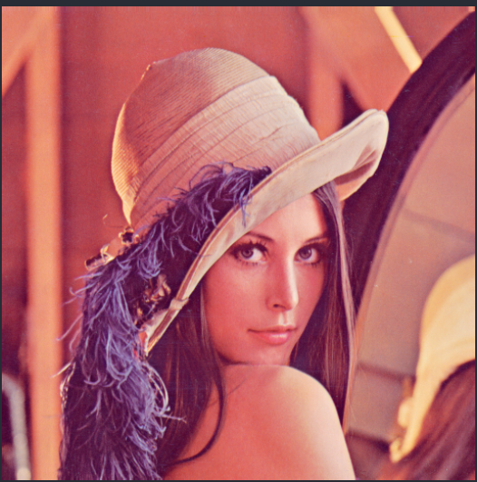

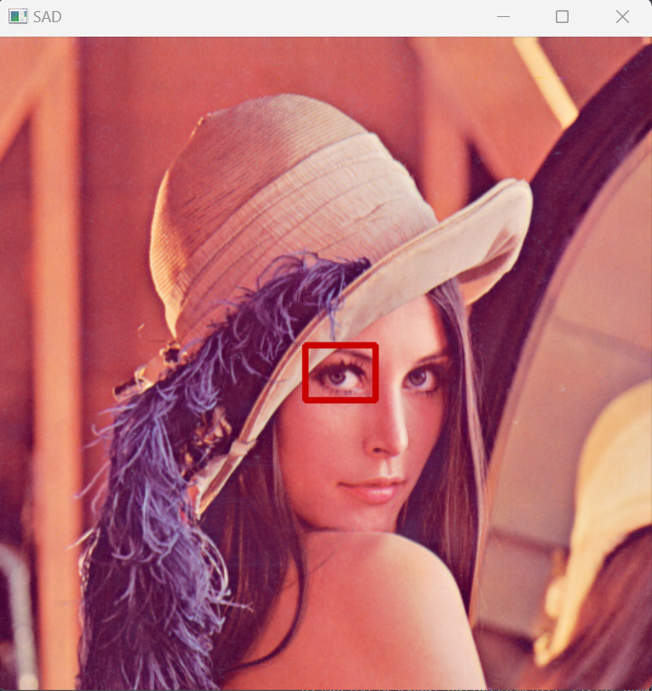

1. **Program SSD**

|  |
| --- |
| import cv2 as cv  import numpy as np  import sys  from matplotlib import pyplot as plt  img = cv.imread(sys.path[0]+"/Lenna.png", cv.IMREAD_GRAYSCALE)  assert img is not None, "file could not be read, check with os.path.exists()"  img2 = img.copy()  template = cv.imread(sys.path[0]+"/Lenna_mata.png", cv.IMREAD_GRAYSCALE)  assert template is not None, "file could not be read, check with os.path.exists()"  w, h = template.shape[::-1]  *# All the 6 methods for comparison in a list*  *#methods = ['cv.TM_CCOEFF', 'cv.TM_CCOEFF_NORMED', 'cv.TM_CCORR',*  *#            'cv.TM_CCORR_NORMED', 'cv.TM_SQDIFF', 'cv.TM_SQDIFF_NORMED']*  methods = ['cv.TM_SQDIFF']  for meth in methods:      img = img2.copy()      method = eval(meth)  *# Apply template Matching*      res = cv.matchTemplate(img,template,method)      min_val, max_val, min_loc, max_loc = cv.minMaxLoc(res)  *# If the method is TM_SQDIFF or TM_SQDIFF_NORMED, take minimum*      if method in [cv.TM_SQDIFF, cv.TM_SQDIFF_NORMED]:          top_left = min_loc      else:          top_left = max_loc      bottom_right = (top_left[0] + w, top_left[1] + h)      cv.rectangle(img,top_left, bottom_right, 255, 2)      plt.subplot(121),plt.imshow(res,cmap = 'gray')      plt.title('Matching Result'), plt.xticks([]), plt.yticks([])      plt.subplot(122),plt.imshow(img,cmap = 'gray')      plt.title('Detected Point'), plt.xticks([]), plt.yticks([])      plt.suptitle(meth)      plt.show() |

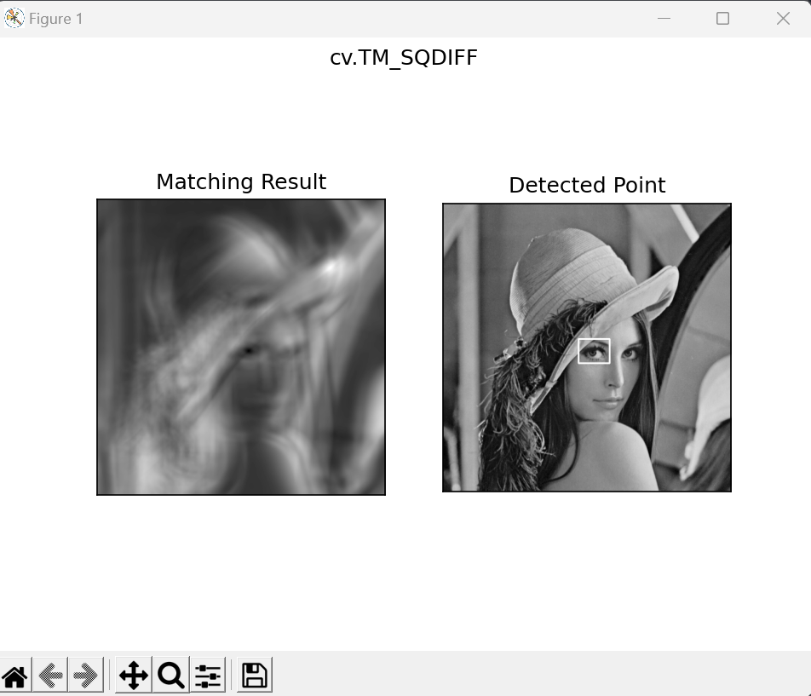

1. **Script program sederhana untuk filter bank dan image pyramid**
2. **Program Filter bank**

|  |
| --- |
| import matplotlib.pyplot as plt  import numpy as np  from scipy import ndimage as ndi  from skimage import data  from skimage.util import img_as_float  from skimage.filters import gabor_kernel  def compute_feats(image, kernels):      feats = np.zeros((len(kernels), 2), dtype=np.double)      for k, kernel in enumerate(kernels):          filtered = ndi.convolve(image, kernel, mode='wrap')          feats[k, 0] = filtered.mean()          feats[k, 1] = filtered.var()      return feats  def match(feats, ref_feats):      min_error = np.inf      min_i = None      for i in range(ref_feats.shape[0]):          error = np.sum((feats - ref_feats[i, :])**2)          if error < min_error:              min_error = error              min_i = i      return min_i  *# prepare filter bank kernels*  kernels = []  for theta in range(4):      theta = theta / 4. * np.pi      for sigma in (1, 3):          for frequency in (0.05, 0.25):              kernel = np.real(gabor_kernel(frequency, theta=theta,                                            sigma_x=sigma, sigma_y=sigma))              kernels.append(kernel)  shrink = (slice(0, None, 3), slice(0, None, 3))  brick = img_as_float(data.brick())[shrink]  grass = img_as_float(data.grass())[shrink]  gravel = img_as_float(data.gravel())[shrink]  image_names = ('brick', 'grass', 'gravel')  images = (brick, grass, gravel)  *# prepare reference features*  ref_feats = np.zeros((3, len(kernels), 2), dtype=np.double)  ref_feats[0, :, :] = compute_feats(brick, kernels)  ref_feats[1, :, :] = compute_feats(grass, kernels)  ref_feats[2, :, :] = compute_feats(gravel, kernels)  print('Rotated images matched against references using Gabor filter banks:')  print('original: brick, rotated: 30deg, match result: ', end='')  feats = compute_feats(ndi.rotate(brick, angle=190, reshape=False), kernels)  print(image_names[match(feats, ref_feats)])  print('original: brick, rotated: 70deg, match result: ', end='')  feats = compute_feats(ndi.rotate(brick, angle=70, reshape=False), kernels)  print(image_names[match(feats, ref_feats)])  print('original: grass, rotated: 145deg, match result: ', end='')  feats = compute_feats(ndi.rotate(grass, angle=145, reshape=False), kernels)  print(image_names[match(feats, ref_feats)])  def power(image, kernel):  *# Normalize images for better comparison.*      image = (image - image.mean()) / image.std()      return np.sqrt(ndi.convolve(image, np.real(kernel), mode='wrap')**2 +                     ndi.convolve(image, np.imag(kernel), mode='wrap')**2)  *# Plot a selection of the filter bank kernels and their responses.*  results = []  kernel_params = []  for theta in (0, 1):      theta = theta / 4. * np.pi      for frequency in (0.1, 0.4):          kernel = gabor_kernel(frequency, theta=theta)          params = f"theta={theta * 180 / np.pi},\nfrequency={frequency:.2f}"          kernel_params.append(params)  *# Save kernel and the power image for each image*          results.append((kernel, [power(img, kernel) for img in images]))  fig, axes = plt.subplots(nrows=5, ncols=4, figsize=(5, 6))  plt.gray()  fig.suptitle('Image responses for Gabor filter kernels', fontsize=12)  axes[0][0].axis('off')  *# Plot original images*  for label, img, ax in zip(image_names, images, axes[0][1:]):      ax.imshow(img)      ax.set_title(label, fontsize=9)      ax.axis('off')  for label, (kernel, powers), ax_row in zip(kernel_params, results, axes[1:]):  *# Plot Gabor kernel*      ax = ax_row[0]      ax.imshow(np.real(kernel))      ax.set_ylabel(label, fontsize=7)      ax.set_xticks([])      ax.set_yticks([])  *# Plot Gabor responses with the contrast normalized for each filter*      vmin = np.min(powers)      vmax = np.max(powers)      for patch, ax in zip(powers, ax_row[1:]):          ax.imshow(patch, vmin=vmin, vmax=vmax)          ax.axis('off')  plt.show() |

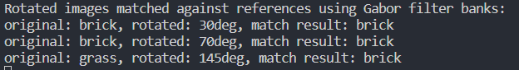

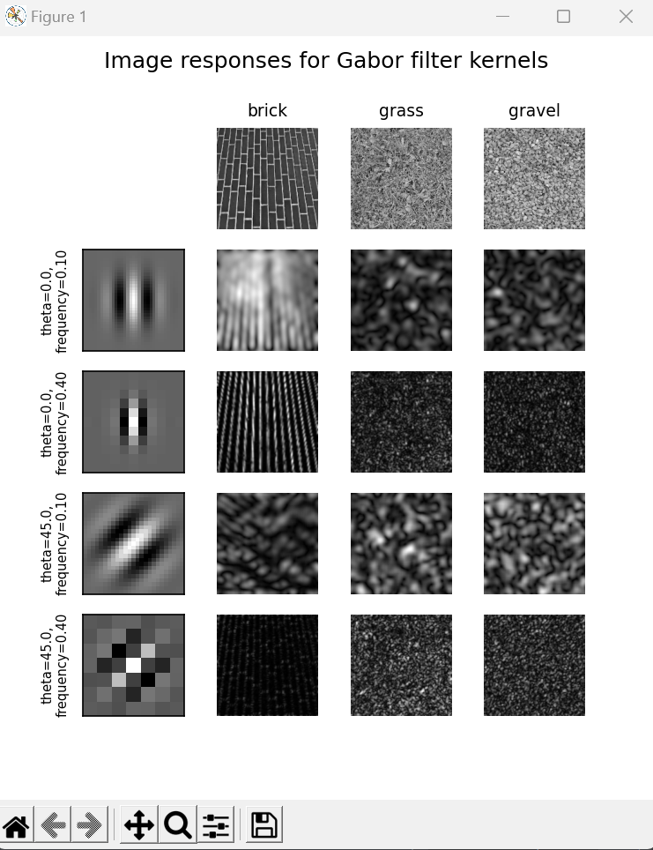

1. **Program Filter image pyramid**

|  |
| --- |
| import numpy as np  import matplotlib.pyplot as plt  from skimage import data  from skimage.transform import pyramid_gaussian  image = data.astronaut()  rows, cols, dim = image.shape  pyramid = tuple(pyramid_gaussian(image, downscale=2, channel_axis=-1))  *# determine the total number of rows and columns for the composite*  composite_rows = max(rows, sum(p.shape[0] for p in pyramid[1:]))  composite_cols = cols + pyramid[1].shape[1]  composite_image = np.zeros((composite_rows, composite_cols, 3),                             dtype=np.double)  *# store the original to the left*  composite_image[:rows, :cols, :] = pyramid[0]  *# stack all downsampled images in a column to the right of the original*  i_row = 0  for p in pyramid[1:]:      n_rows, n_cols = p.shape[:2]      composite_image[i_row:i_row + n_rows, cols:cols + n_cols] = p      i_row += n_rows  fig, ax = plt.subplots()  ax.imshow(composite_image)  plt.show() |

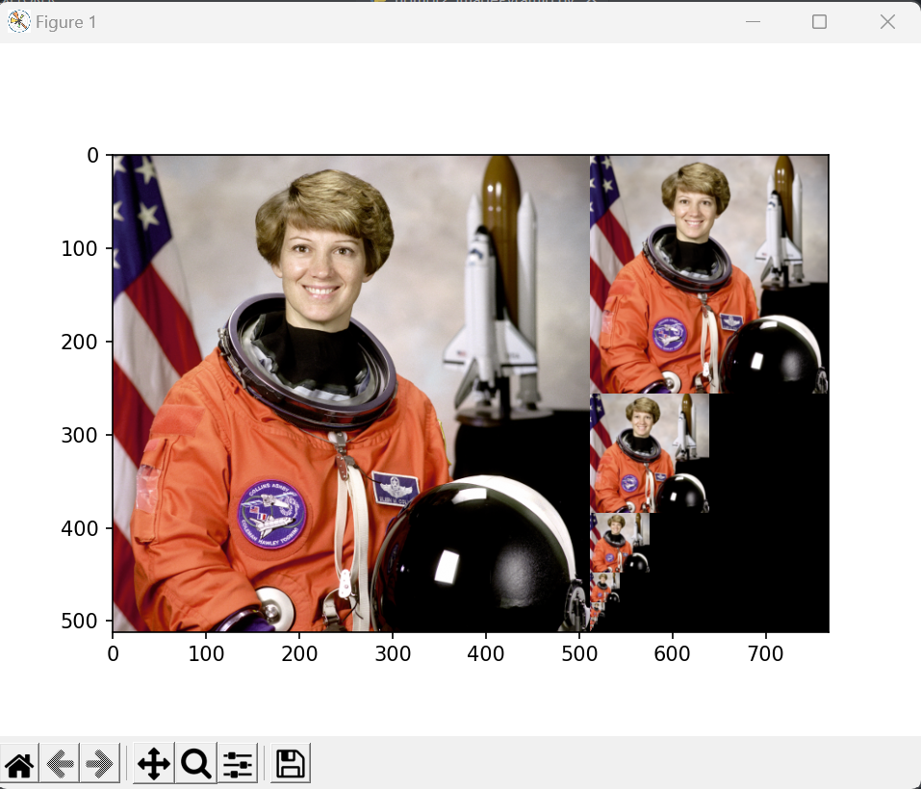

1. **Script program sederhana untuk metode ohlander**

|  |
| --- |
| import cv2  import numpy as np  import sys  *# Fungsi untuk melakukan segmentasi menggunakan metode Ohlander's Recursive Histogram-Based Clustering*  def ohlander_clustering(image, threshold):      if len(image.shape) > 2:          gray_image = cv2.cvtColor(image, cv2.COLOR_BGR2GRAY)      else:          gray_image = image.copy()  *# Mendapatkan histogram dari gambar*      hist = cv2.calcHist([gray_image], [0], None, [256], [0, 256])  *# Mencari nilai untuk clustering*      split_value = 0      max_val = np.max(hist)      for i in range(255, 0, -1):          if hist[i] > threshold * max_val:              split_value = i              break  *# Segmentasi gambar*      segmented_image = np.zeros_like(gray_image)      segmented_image[gray_image >= split_value] = 255      return segmented_image  input_image = cv2.imread(sys.path[0]+'/bola2.jpg')  threshold_value = 0.7  segmented_image = ohlander_clustering(input_image, threshold_value)  cv2.imshow('Original Image', input_image)  cv2.imshow('Segmented Image', segmented_image)  cv2.waitKey(0)  cv2.destroyAllWindows() |

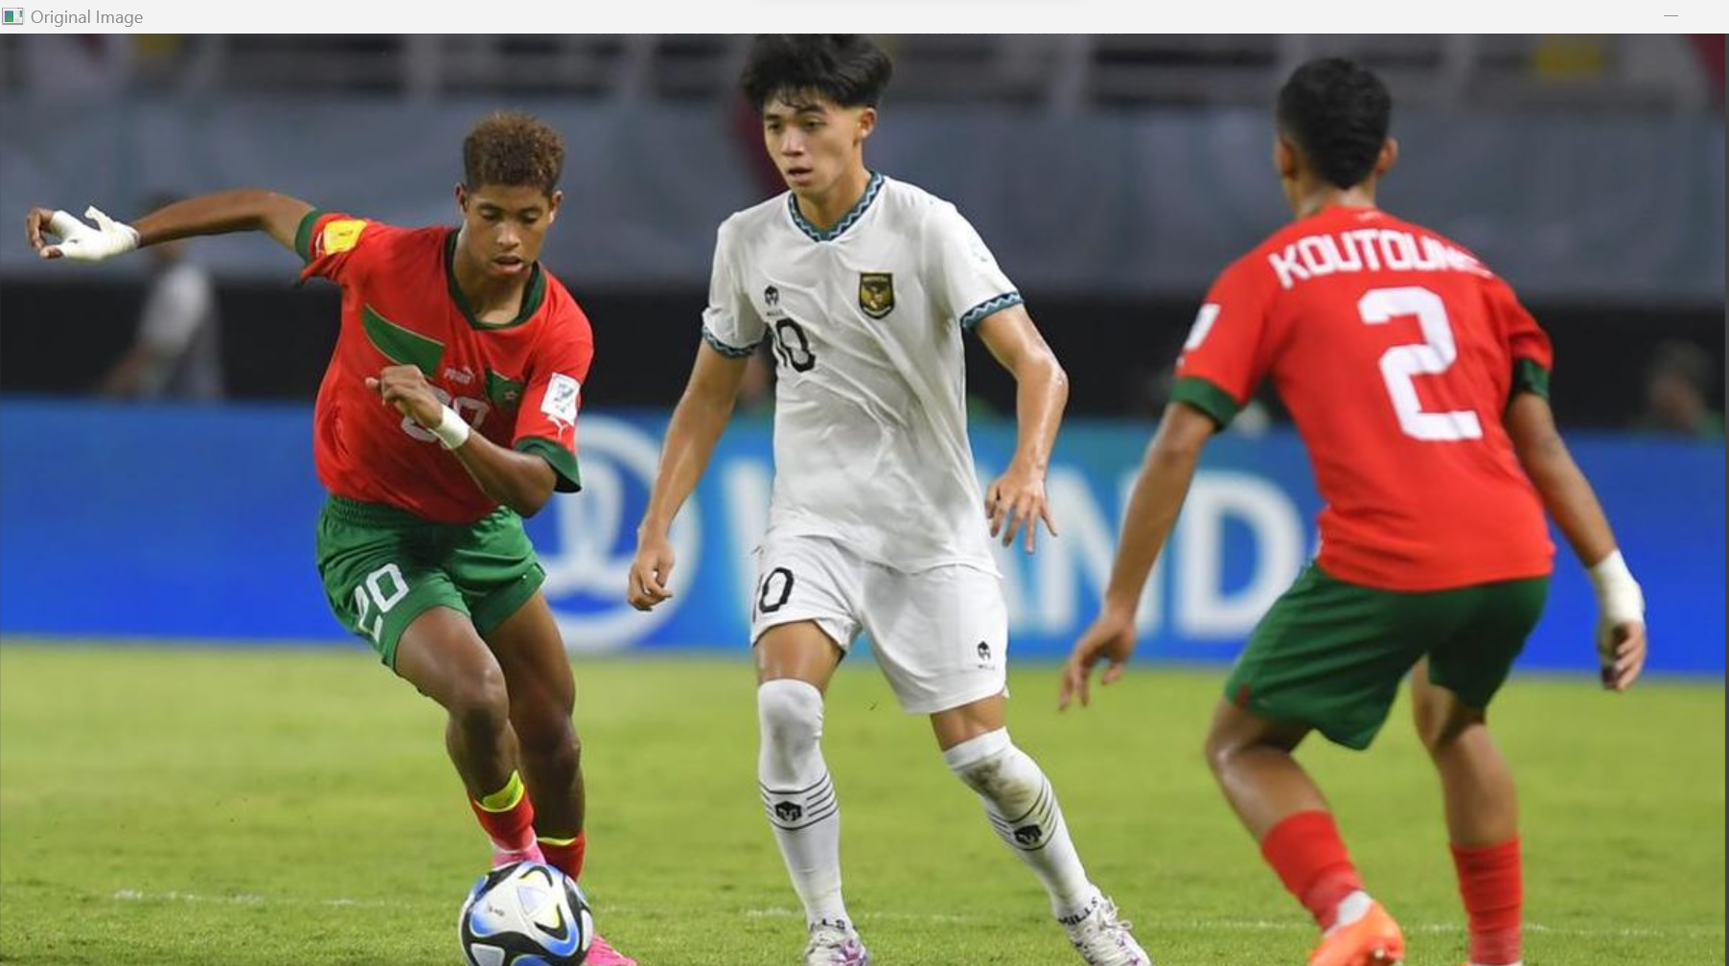

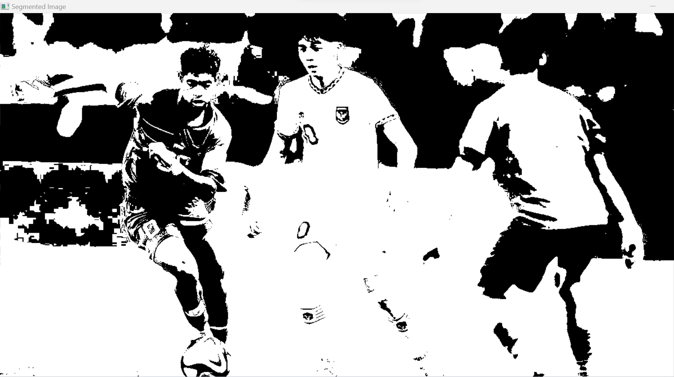

1. **Script program sederhana untuk transformasi hough untuk mendeteksi lingkaran**

|  |
| --- |
| import cv2  import numpy as np  import sys  *# Baca gambar*  img = cv2.imread(sys.path[0]+"/lingkaran.jpg", cv2.IMREAD_GRAYSCALE)  *# pre-processing*  imgm = cv2.medianBlur(img,5)  imgb = cv2.cvtColor(imgm, cv2.COLOR_GRAY2BGR)  *# Deteksi lingkaran menggunakan Hough Transform*  circles = cv2.HoughCircles(      imgm,      cv2.HOUGH_GRADIENT,      1,  *# Resolusi ruang akumulator yang diinginkan (semakin kecil semakin akurat, tapi juga membutuhkan lebih banyak waktu)*      50,  *# Jarak minimum antara pusat dua lingkaran yang dideteksi*      param1=100,  *# Parameter deteksi tepi (semakin tinggi, semakin ketat)*      param2=50,  *# Parameter ambang batas untuk memilih pusat lingkaran (semakin kecil, semakin ketat)*      minRadius=0,  *# Radius minimum lingkaran yang akan dideteksi*      maxRadius=100  *# Radius maksimum lingkaran yang akan dideteksi*  )  *# Jika lingkaran ditemukan, gambar mereka pada gambar asli*  if circles is not None:  *# cari koordinat x,y dan radius (r)*     circles = np.round(circles[0, :]).astype("int")     print(circles)  *# cari terus dlm loop*     for (x, y, r) in circles:        cv2.circle(imgb, (x, y), r, (0, 255, 0), 2)  *# Tampilkan hasil*  cv2.imshow('Deteksi Lingkaran', imgb)  cv2.waitKey(0)  cv2.destroyAllWindows() |

